LESSON PLAN (4)

HOW TO START A NEW COMPANY?

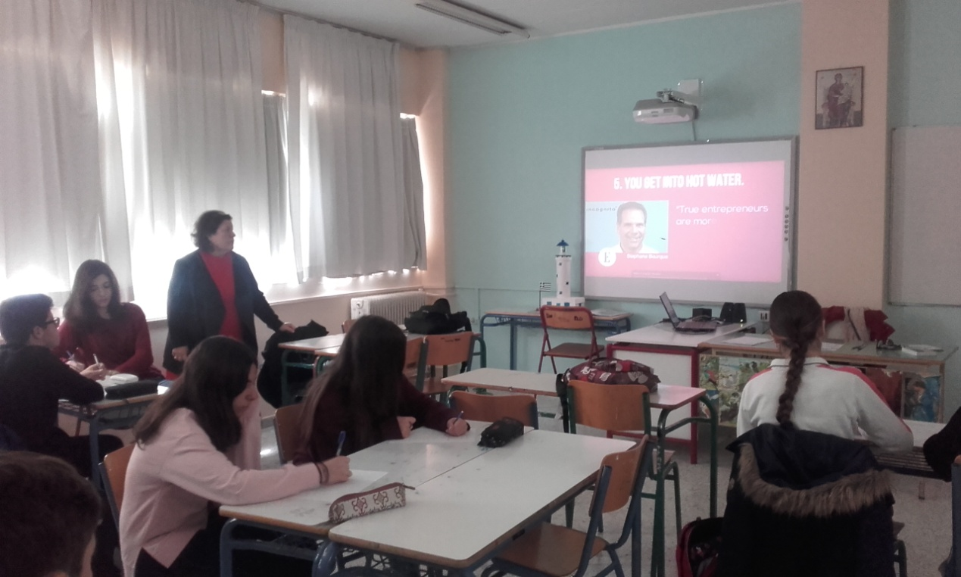

School: 1st High School of Cholargos
Teachers: Christina Bravou (Greek Literature and History teacher) and Despina Makridimitri (English teacher)
Time: 50’
Age: 14-15
OBJECTIVES: Having known about the demands of enterprising, the characteristic of a good businessman, they find out if they have the potential characteristics to become entrepreneurs. Students also learn new vocabulary and practice English.
OUTCOMES: students will get a sufficient knowledge of the qualification of a good businessman.
The whole class takes part in the procedure. Students attend short videos about businessmen. They learn how to start their company. One of the steps, they firstly make is to find a good, innovative idea.
PROCEDURE: First, warmer, brainstorm.
- Students talk about entrepreneurship and define the meaning of the word. Then, teachers assign them to think of English words about entrepreneurship and entrepreneurs.
- Each student has to find 10 adjectives at least to describe a successful businessman. For example give adjectives such as: innovative, enthusiastic, assertive, clever, open-minded risky, flexible optimistic, self- confident etc.
- They have been asked to tell an example about a businessman they knew: the kind of company he had and how to start it.

- Then, teachers show them a power point about young Greek entrepreneurs who had very innovative ideas and they managed to establish successful companies.
- They discuss what inspired them to have such an idea. They have to answer to the following question:

“Could you think of some factors or circumstances making somebody find a good idea?”

They give many answers. The conclusion is that:

if somebody wants to find out a good idea for your company, he has to:
- stay curious.
- keep his mind open to new ideas and embracing novelty.
- believe in himself.
- start with something that he enjoys doing
- be passionate with his idea

Then, they are divided into groups and play roles. They have to think of an idea for a new company and discuss with the other members of the group.

Finally, they present the idea for a successful company, they have found. They should justify why they think this idea could be effective and which needs it is going to cover.

Author: Christina Bravou
