SPROTNA PRIPRAVA NA POUK  Erasmus projekt YEE – 4. mobilnost  mag. Urška Bučar, Nina Pavlin |  | Datum:
UČNE OBLIKE:  frontalna, individualna, skupinska | UČNE METODE:  opisovanje, razlaga, pripovedovanje, razgovor, opazovanje, delo z ICT | UČNI PRIPOMOČKI:  Računalnik, kamera, telefon, snemalnik zvoka, programi za montažo videa, tablice
Cilji | Dejavnosti
- Spozna ključne dejavnike dobrega oglaševanja  - Pripravi scenarij reklame za lastno podjetje in prodajo izdelka  - Izpostavi bistvo svojega oglasa  - Uporabi ustrezno tehnologijo za izdelavo/montažo oglasa  - Izdela učinkovito zgodbo za prodajo  - Predstavi izdelek preko oglasa za prodajo | Uvodna motivacija:  - predstavimo oglase tretješolcev  Uvodni del:  - analiziramo vprašalnike, ki so jih izpolnili pred mobilnostjo (vprašalniki so v prilogi 1)  - pogovorimo se o najboljših predlogih  - glede na analizo dodamo nove predloge  Glavni del:  - pripravimo scenarij, zgodbo (priloga 2)  - izpolnimo časovnico (priloga 3)  - montiramo izdelek v izbranem programu  Zaključni del:  - prestavitev reklam

Erasmus+ project YEE – 4. mobility
LESSON PLAN
UNIT TITLE: Creating an advertisement  SUBJECT:  GRADE: |  | TEACHER: mag. Urška Bučar, Nina Pavlin  DURATION: 45 min
OBJECTIVES & OUTCOMES
Students will:
- realize the key factors of good advertising,
- prepare a script for his own business advertisement and selling of a product,
- establish the essence of his ad,
- use appropriate technology to create / edit the ad,
- produce an effective story for sale,
- introduce the product through an ad.
MATERIALS  - computer,  - camera,  - phone,  - sound recorder,  - video editing programs,  - tablet |  | MODIFICATION & DIFFERENTIATION  If some students need extra help, the other teacher can work with them in small groups. Teacher can give advice on topics. Teacher should be monitoring progress along the way in order to be certain that students conceptually understand the task at hand.
ASSESMENT & EVALUATION
Students will present our work to their fellow students and teachers.

TIMING | TEACHER ACTIVITIES |  | STUDENTS ACTIVITIES
OPPENING TO LESSON  5 min | INTRODUCTION  I start with the introduction: I tell them my name and about my work and experience.  ICEBREAKER ACTIVITY  I show them the ads of my former third graders. |  | Take turns to introduce themselves.  Active listening and watching.
BODY OF LESSON  30 min | INTRODUCING TOPIC  Analyzing the questionnaires that have been completed before mobility (Annex 1)  Talk about the best suggestions.  Adding new proposals according to the analysis. |  | Active listening  Take notes  Share experience
 | MAIN PART:  Preparing a script, a story (Annex 2).  Filling in the timetable (Annex 3).  Mounting shots in the selected program. |  | They make groups by country.  Each group prepare a script, fill in the timetable an create an ad.
CLOSING  10 min | Presenting ads.  Questioner (Annex 4). |  | They choose one learner to present their ad.  Answering questioner.

Annex 1:
How to Create an Effective Video Ad for Your Small Business - Marketing & Sales
(YOUR HOMEWORK THAT MUST BE DONE BEFORE MOBILITY):
Video marketing is a strategy that every small business owner should consider. Not only is this form of marketing effective for increasing sales and brand recognition, but, it’s also preferred by customers.
Depending on your audience, most markets would rather watch an informative video about your company than scroll down a long page of text. Right now, digital video advertising is a top marketing trend, and your small business can get involved by creating an online video ad.
An informative online video advertisement is a great tool for converting interest into sales and growing your brand on the web. Whether that’s on your website, Facebook page, YouTube channel, eNewsletter or any other way that you market to your customers.
What to Consider When Creating a Video Ad?
Now you understand how to create a response to your video ad – what else do you need to consider in the creative process? Here are a few additional tips to keep in mind when creating an online video ad for your small business.
Solve a Problem – What problem is your business solving? How are you doing so? A good video ad will highlight a problem, and show viewers how it will be solved by the brand.
Use a Script – It’s essential to have a well put together plan before creating content in any format, especially when it comes to video. Don’t try to wing it! Create a script for your video ad that includes the important components mentioned above. After doing so, get it reviewed by friends, family, and those with a good understanding of your brand. Feedback is extremely valuable for making the necessary adjustments.
Choose a Platform – Once you’ve produced and edited your video ad, it’s important to upload the content to a quality platform. Video hosting issues are the last thing you want. At the moment, YouTube, Vimeo and Facebook are the most popular and reliable choices for uploading video content. You can use all three options to extend the reach of your video.
Get Creative – Online viewers are used to seeing commercials online and clicking away. Choose a unique format or style that allows your brand to promote itself while appealing to your target market. The more creative you get, the more your video will stand out from the content of competitors.
Keep these tips in mind as you plan and create an online video ad for your small business. Whether your goal is to increase sales, or brand recognition, you’ll find video marketing to be an effective strategy.

How to Make Your Video Ad Effective?
1. Make the First Few Seconds Count
The beginning of your video is critical. To avoid having potential customers skip your ad or click away, you need to get their attention immediately. Start your video ad with a statement that will spark the interest of those in your target market. Make an effort to hook your audience within the first few seconds by (insert your suggestions):
- addressing a common problem:
___________________________________________________________________________________________,
- asking a relevant question:
___________________________________________________________________________________________,

- sharing something that makes your brand stand out:
___________________________________________________________________________________________.
- if you’ll notice that video ads can be on mute, therefore it’s also important to start your ad with great visuals that encourage viewers to take interest to your video:
___________________________________________________________________________________________.

2. Highlight What Makes Your Brand Great
Why should viewers be interested in your brand? Answer this question in your video ad by:
- emphasizing what makes your company great at what it does:
___________________________________________________________________________________________
___________________________________________________________________________________________
- tell viewers why your brand is unique and different from others:
___________________________________________________________________________________________
___________________________________________________________________________________________
- share your achievements:
___________________________________________________________________________________________
___________________________________________________________________________________________
- showcase your track record for success or you can even include customer testimonials and positive feedback:
___________________________________________________________________________________________
___________________________________________________________________________________________
The more you highlight the benefits of your company, the more effective your video ad will be.

3. Tell Viewers Why
Your video should tell viewers:
- why they should choose your brand:
___________________________________________________________________________________________
___________________________________________________________________________________________
- what is it that makes your products or services, “the right choice”:
___________________________________________________________________________________________
___________________________________________________________________________________________

Whether it’s a great value, unlimited warranty, or patented technology for creating a unique product, you need to give viewers a reason to go with your company. It’s important to emphasize this when planning and filming your online video ad.

4. Use a Call to Action
The goal of every advertisement is to encourage people to take some sort of action. Your advertisement should be no different. The call to action (CTA) can either be filmed or added through graphics and text.
Ideally, it’s best to include the CTA at the end of the video. Write down to viewers how they can visit your website for more info, sign up for a discount, or purchase your products and services:
____________________________________________________________________________________________
____________________________________________________________________________________________
____________________________________________________________________________________________

5. Put together a plan.
To figure out what type of message you’d like to convey, consider the following questions:
- Are you promoting a new product or service? _______________________________________________

- Do you have a “special offer” that you want to emphasize?
___________________________________________________________________________________________
- How does your product or service make your customer’s life easier, better or happier?
___________________________________________________________________________________________
___________________________________________________________________________________________

- For making video add you should prepare ad different material (YOUR HOMEWORK THAT MUST BE DONE BEFORE MOBILITY):

- personalize the video with pictures of yourself, your employees and your customers
- if you have customer testimonials, include them (video)
- if possible, show a customer using your product or service (video)
- prepare video or pictures, that presents how you produce your product. Check the lighting. If you don’t have professional lighting, make sure your video is recorded during the day in front of a window, and turn on the overhead lights. Consider wardrobe. The “actors” in your video should wear neutral-colored, clean, attractive clothing. You want your customers focusing on your message, not on your clothing (unless of course you’re a clothing retailer in which case the above doesn’t apply!)
- find a voice. If you’re not comfortable speaking in front of a camera, have someone else record your message for you, which can then be laid in over your chosen visuals
- consider about telling the story: Select an appropriate setting. If you have a restaurant, you might want to capture your chef at work in the kitchen. If you are a service business, like a plumber, show one of your employees arriving at your customer’s door in a spotless uniform bearing your logo. Your video reflects your business so be sure to present the image that you want your customer to remember.
- Include a “call to action.” Give your customers a reason to click through to your business from your video ad. This can simply be your contact information, but a coupon or special offer couldn’t hurt. You may want to consider creating a special landing page that corresponds specifically to the message in your video. From there, visitors can easily explore the rest of your site.

- Look at some of (by your opinion) the best adds

Annex 2:
Write a script – WORKSHOP FOR MOBILITY
Timing Your Video Ad
Don’t try to wing it; it usually doesn’t work. You know your business best, so you are probably the best person to tell people about it.
Keep it short and sweet. A typical advertising video should last no more than 30 seconds. It may easier to shoot multiple short clips that can be combined later rather than one long video that must be edited down. You may have to shoot multiple short videos to get the look and feel you want.
Avoid turning your advertisement into a documentary. A majority of the video ads online are 30 seconds or less. Keep this optimal length in mind as you create the script for the video.
That being said, if you are using videos for brand positioning, longer videos can be effective as well. For example, if you’re telling a story about your brand that features a customer or company representative, a longer video would be ideal.
Either way, it’s essential to eliminate unnecessary content, and spread your message as quick as possible to keep viewers watching and engaged.

Annex 3
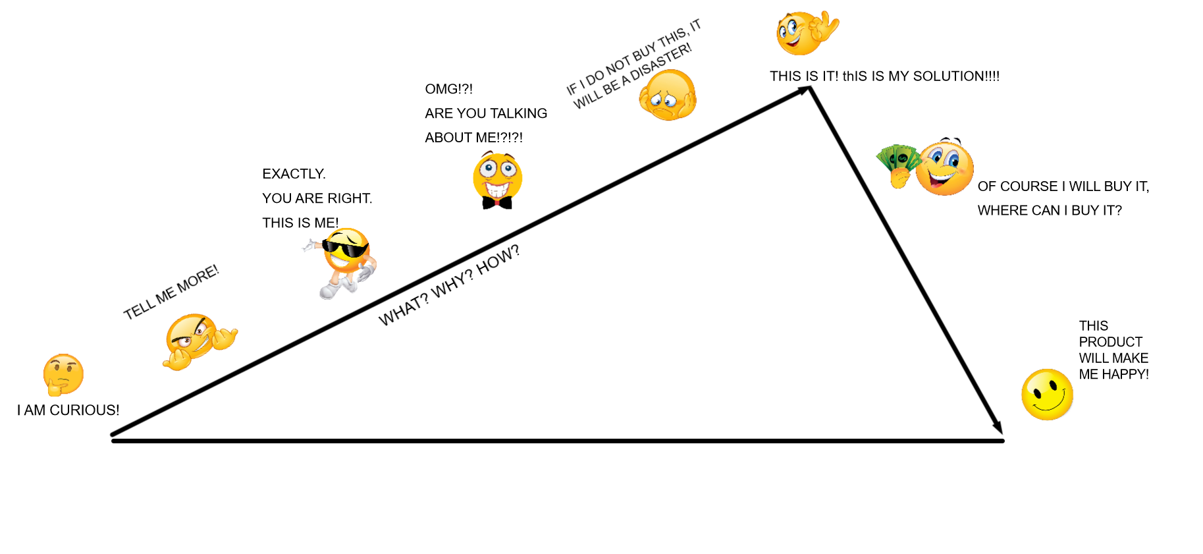

Annex 4:
QUESTIONNAIRE
- Activities were useful. 1 2 3 4 5
- The teacher was understandable. 1 2 3 4 5
- The pace of the activities?
too slow just right too fast
- What did you like best or find most useful about the workshop?
_______________________________________________________________
- I felt…
- I suggest…
_______________________________________________________________

QUESTIONNAIRE
- Activities were useful. 1 2 3 4 5
- The teacher was understandable. 1 2 3 4 5
- The pace of the activities?
too slow just right too fast
- What did you like best or find most useful about the workshop?
_______________________________________________________________
- I felt…
- I suggest…
_______________________________________________________________

